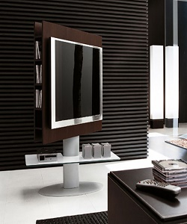

TV trolley

$79.73

Availability: In stock

### Description

Standard Finish in Black or Extra White Glass Available Special Order in Red or Extra White Champagne Glass. Satin stainless steel frame, Concealed wiring, Glass shelf, Swivel functionality.